Q1.
Answer is B.

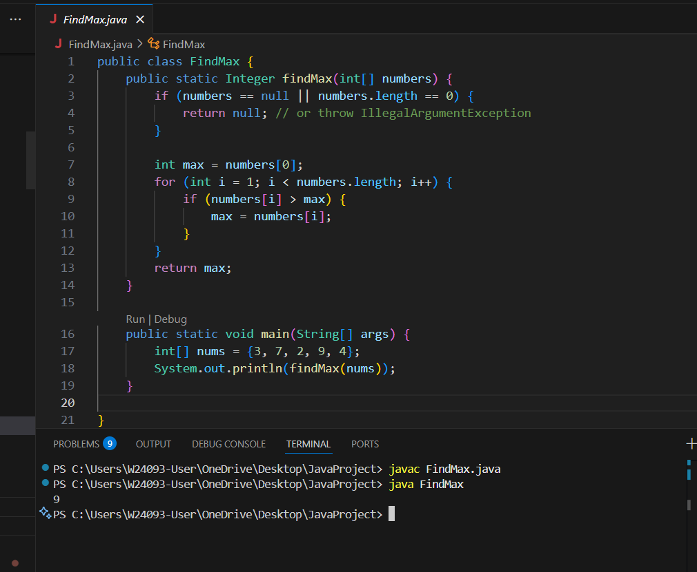

A: Not the cause

B: causes wrong result with negative arrays.

C: Loop is fine, goes through all elements.

D: Not the cause.

Q2.
Answer is A.

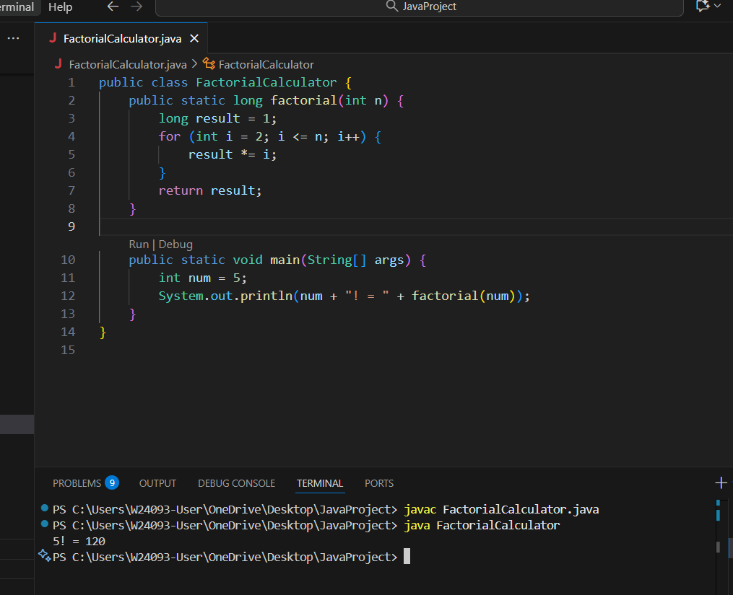

A: Simplest and correct.

B: Not solving the issue mentioned in the question.

C: Risk of incorrect results for larger numbers.

D: Also a correct alternative, though more advanced syntax than A.

Q3.
Answer is B.

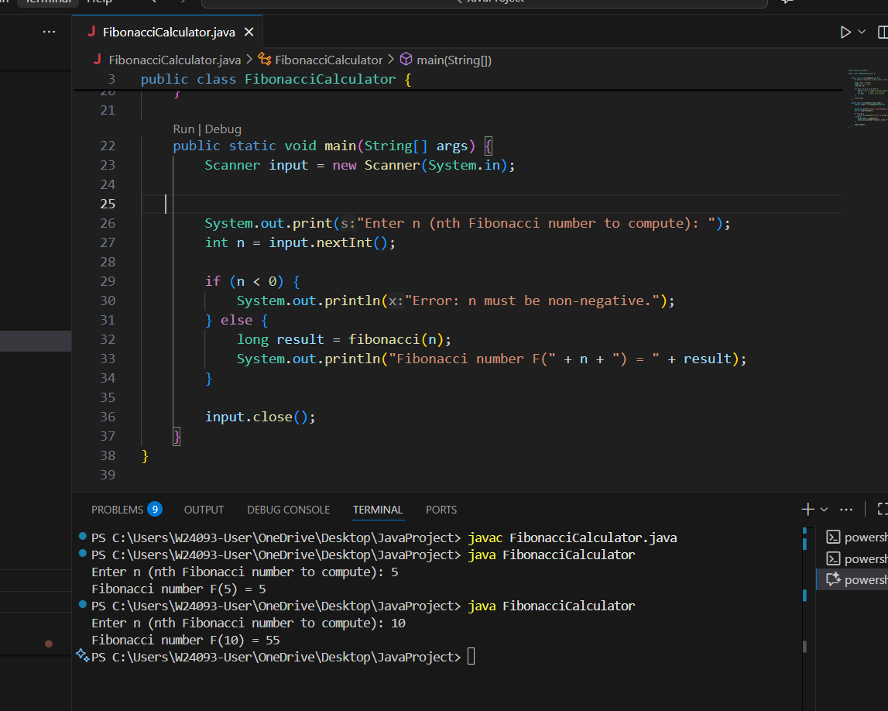

A: There are no arrays in this method.

B: Correct.

C: also valid.

D: But in practice, before n reaches 1000, the exponential time problem already makes it unusable.

Q4.
Answer is D.

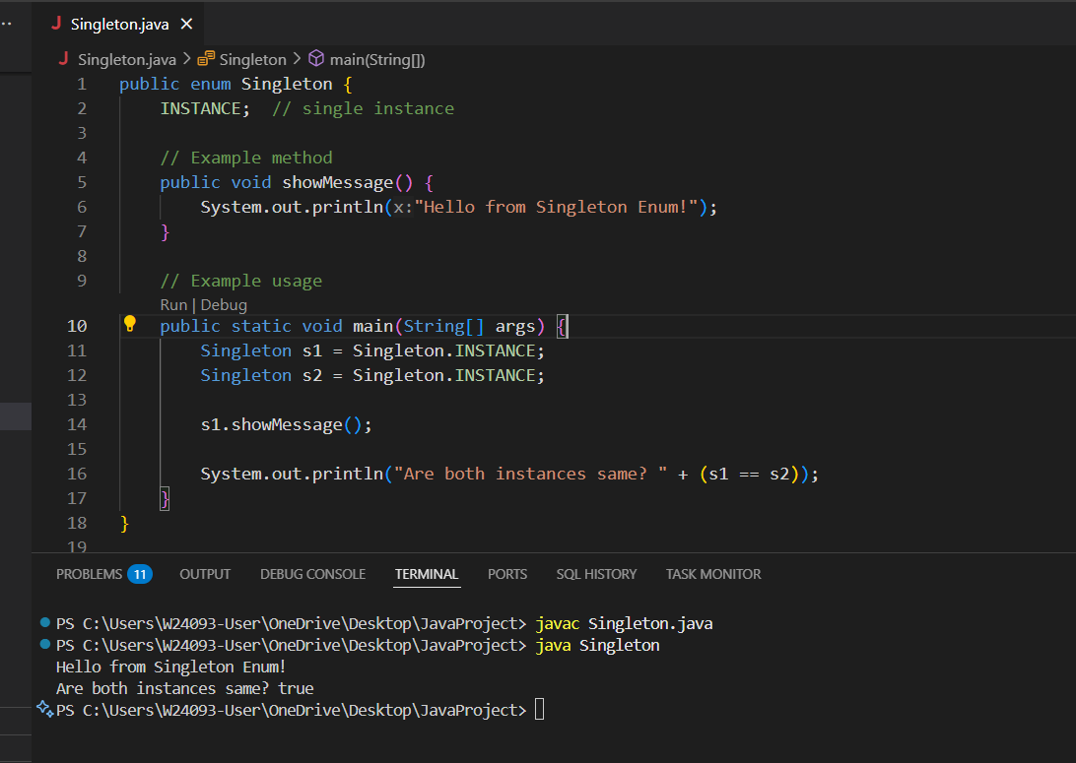

A: Works, but not efficient.

B: Simple but not lazy-loaded.

C: Work.

D: Correct.

Q5.
Answer is C.

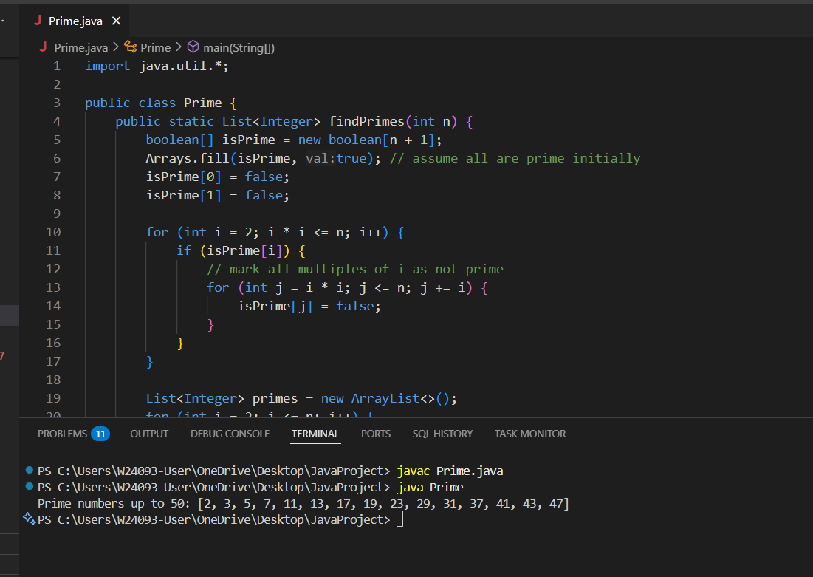

A: Incorrect.

B: work but still slow for large n.

C: Correct. Faster than B.

D: Not efficient for this case.

Q6.
Answer is D.

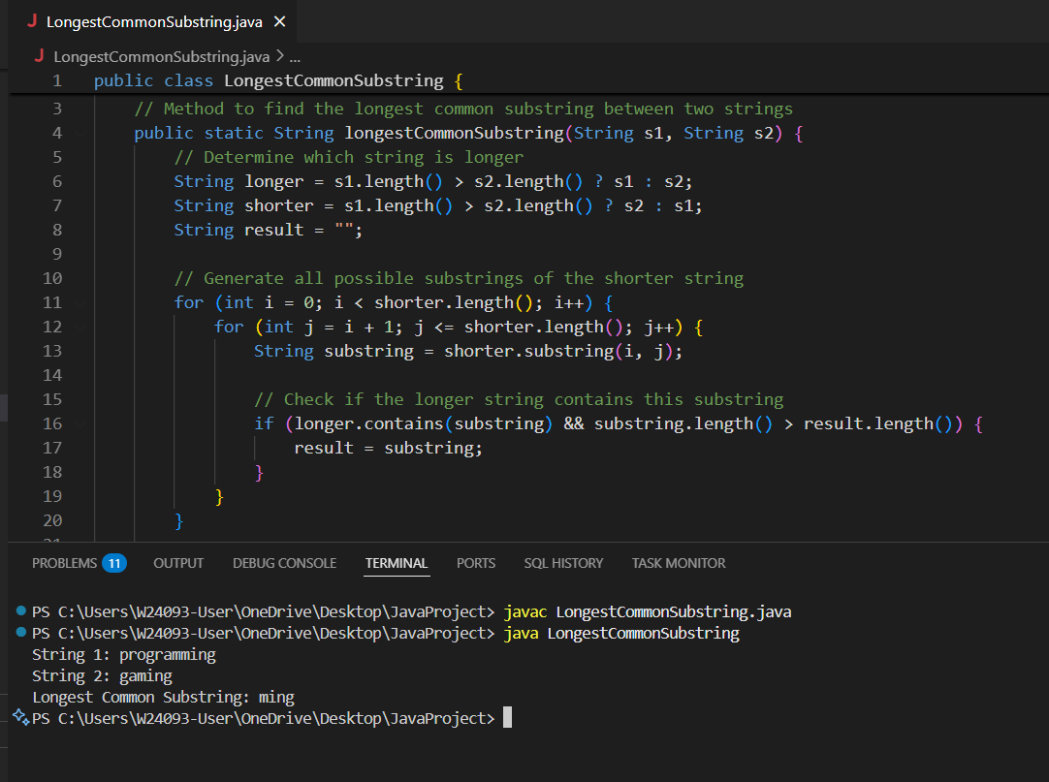

Two nested loops → O(n²) substrings
Each substring check → O(n)
Therefore → O(n³) overall
Final Answer: D. O(n³)

Q7.
Answer is B.

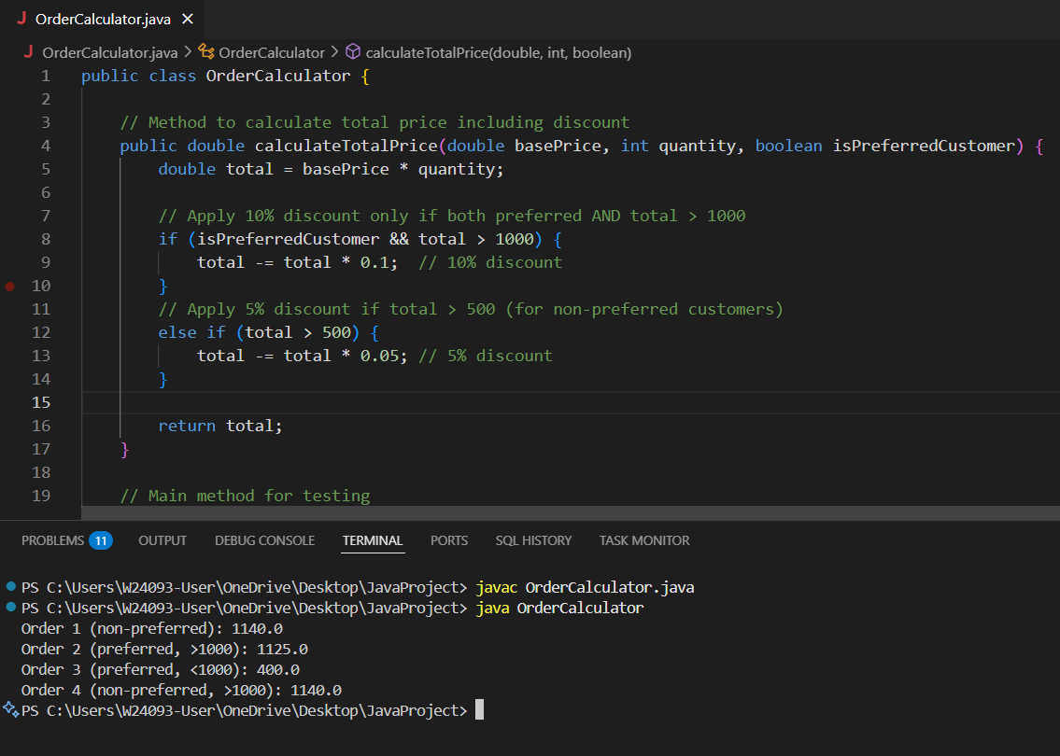

A: Discount formula is fine.

B: Bug: Logical operator should be && instead of ||.

C: Correct Calculation.

D: Correct return statement.

Q8.
Answer is B.

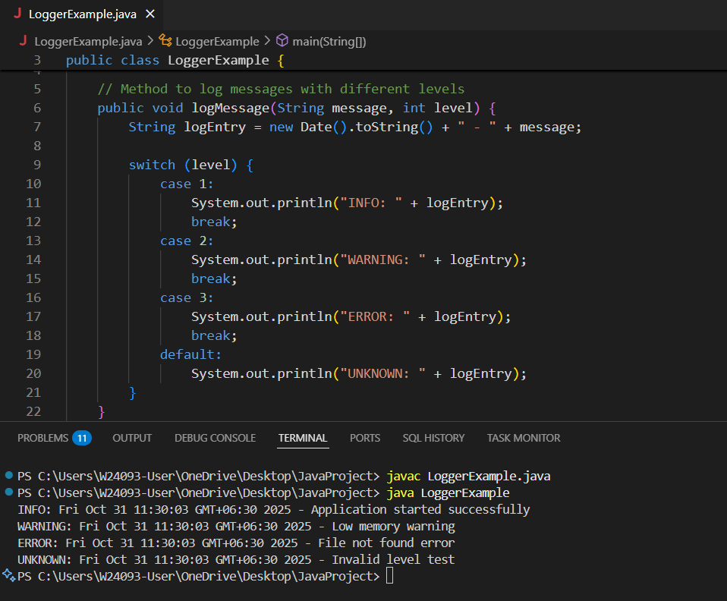

A: Wrong Logic.

B: By replacing if-else chain with switch statement is readable and maintainable.

C: Hard to read and maintain — confusing nested ? : expressions.

D: Works correctly but slightly less readable than switch.

